
www.bradyidpal.com
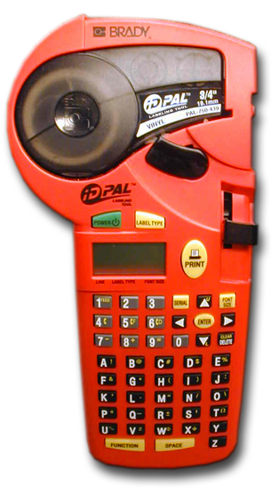

Instructions
PRODUCT REGISTRATION
Register on-line at www.bradyidpal.com for FREE impact guards and to extend your warranty from six months to one full year.
POWER Batteries
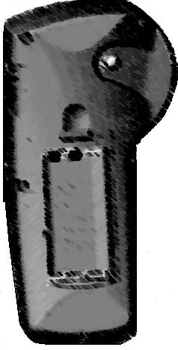


- Open battery compartment.
1
2
- Insert six AA alkaline batteries.
- Close battery compartment.
-or-

A/C Power
Plug in optional A/C Power Supply.
3

DISPLAY

123
2 GEN S
Text
Line
Label type/
Wiremarker length
Font size (S, M, L, X, XX)

CREATE LABELS
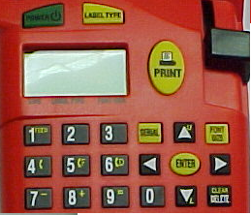
2
1
3
5
6
- Press
- *Press
General, Banner,
or Wire/Length
(0.75”, 1.0”, 1.2”,
1.5”, 2.0”, 2.5”, 3.0”,
4.0”, 5.0”, 6.0”)
*Use multiple presses to scroll through selections. FUNCTION + key scrolls backwards.

- *Press
7 pt (S) 10 pt (M), 14 pt (L),
20 pt (X), 28 pt (XX)
- Enter Text
6
Max. Printable Lines=
General & Wire: 4 Lines
Banner: 2 Lines


Press
Locking Lever must be locked to print. See Change Label Cartridge.
- Cut Label—slide cut lever up
GEN

WIRE
WIRE
BANNER
SERIALIZATION
- Use arrows   to place cursor under serial character.
WIRE1
1 W.75 S
- Press for each consecutive serialization.
CHANGE LABEL CARTRIDGE
WIRE1
1 W.75 S
To produce multiple copies of the same legend, press PRINT before SERIAL .

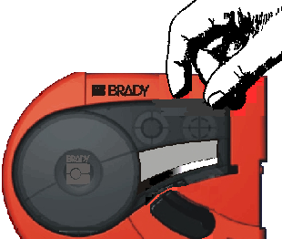
Unlock Lever
Push Release
Button (on back)
Remove Old
Cartridge
Insert New Cartridge
Lock Lever
2

1
4
KEYPAD
FUNCTION | PRESS
Uppercase |  + 
Lowercase | + 
New Line
Space | 
Font Size
Delete Character
Clear Legend | +
Feed | +
SYMBOLS
Press + Character
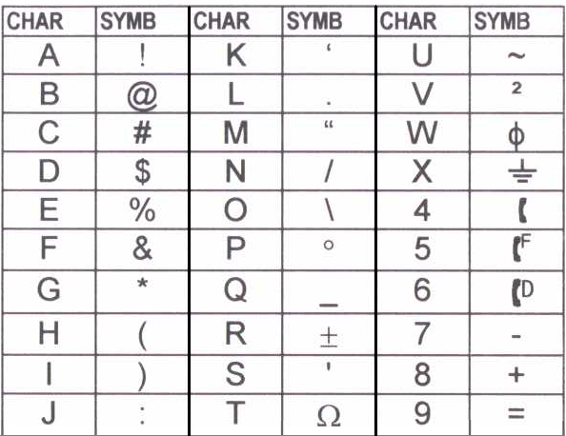Prints as
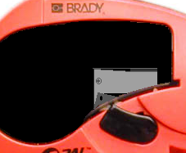
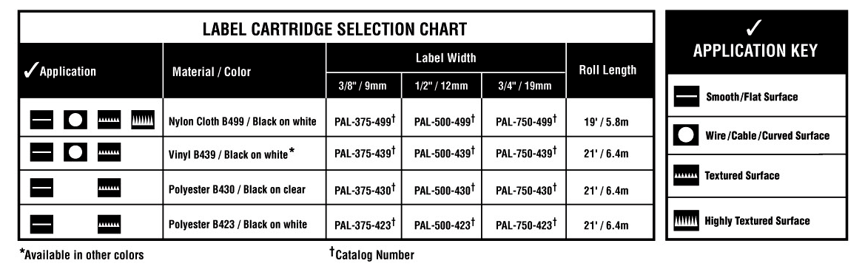
2
CLEANING INSTRUCTIONS

- Remove Label Cartridge.
- Wipe the printhead and platen roller with a cotton swab saturated with isopropyl alcohol.
Cleaning is recommended after each cartridge.

IDENTIFICATION SOLUTIONS & SPECIALTY TAPES
P.O. Box 2131  Milwaukee, Wisconsin 53201-2131 U.S.A.
Phone 1-800-537-8791  www.bradyidpal.com
REV. B 12/01
Y92829

